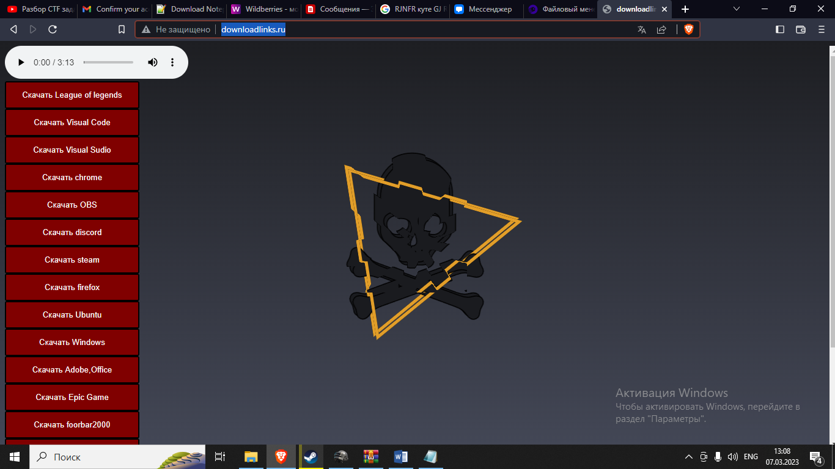

Рис.1 Страница сайта с анимацией

Файл Html

<!DOCTYPE html>

<html lang='en-ru'>

<style>

.layer {

overflow: auto;

/* Добавляем полосы прокрутки */

width: inherit; /* Ширина блока */

height: inherit;

}

</style>

<head>

<link rel="shortcut icon" href="/public_html/billy.ico" type='image/jpg'>

<link rel='stylesheet' type='text/css' href='style.css'>

<div class='headbackground'>

<meta charset='UTF-8'>

<meta http-equiv='X-UA-Compatible' content='IE=edge'>

<meta name='viewport' content='width=device-width, initial-scale=1.0'>

</div>

</head>

<body>

<div class="layer"/>

<audio controls>

<source src="три дня дождя, лали - космос ♡speed up♡ ♡nightcore♡.mp4" type="audio/ogg; codecs=vorbis" loop="-1">

<source src="три дня дождя, лали - космос ♡speed up♡ ♡nightcore♡.mp4" type="audio/mpeg" loop="-1">

Тег audio не поддерживается вашим браузером.

<a href="три дня дождя, лали - космос ♡speed up♡ ♡nightcore♡.mp4" loop="-1">Скачайте музыку</a>

</audio controls>

<form action=https://brave.com/ru/download/>

<form action=https://signup.leagueoflegends.com/ru-ru/signup/redownload?page_referrer=index><button class='btn' >Скачать League of legends</button></form>

<form action="https://code.visualstudio.com/download"><button class='btn' >Скачать Visual Code</button></form>

<form action="https://visualstudio.microsoft.com/ru/vs/"><button class='btn' >Скачать Visual Sudio</button>

</form><form action="https://www.google.com/intl/ru_ru/chrome/"><button class='btn' >Скачать chrome</button></form>

<form action="https://obsproject.com/ru/download"><button class='btn' >Скачать OBS</button></form>

<form action="https://discord.com/download"><button class='btn'>Скачать discord</button></form>

<form action="https://store.steampowered.com/about/Steam?l=russian"><button class='btn' >Скачать steam</button></form>

<form action="https://www.mozilla.org/ru/firefox/new/"><button class='btn' >Скачать firefox</button></form>

<form action="https://ubuntu.com/download/desktop"><button class='btn' >Скачать Ubuntu</button></form>

<form action="https://www.microsoft.com/ru-ru/software-download/windows10ISO"><button class='btn' >Скачать Windows</button></form>

<form action="https://download-windows.org/"><button class='btn' >Скачать Adobe,Office</button></form>

<form action="https://store.epicgames.com/ru/download"><button class='btn' >Скачать Epic Game</button></form>

<form action="https://www.softportal.com/getsoft-2490-foobar2000-1.html"><button class='btn' >Скачать foorbar2000</button></form>

<form action="https://www.wacom.com/ru-ru/products/inkspace"><button class='btn'>Скачать Inkspace</button></form>

<form action="https://natrongithub.github.io/"><button class='btn'>Скачать Natron</button></form>

<form action="https://www.gimp.org/"><button class='btn'>Скачать Gimp</button></form>

<form action="https://www.blackmagicdesign.com/products/davinciresolve"><button class='btn'>Скачать Davinci Resolve</button></form>

<form action="https://www.youtube.com/watch?v=DyuAUK9LAXY"><button class='btn'>Твич ростика</button></form>

</div>

<svg id="hs" width="400" height="400" xmlns="http://www.w3.org/2000/svg">

<defs>

<filter id="glow">

<fegaussianblur class="blur" result="coloredBlur" stddeviation="8"></fegaussianblur>

<femerge>

<femergenode in="coloredBlur"></femergenode>

<femergenode in="coloredBlur"></femergenode>

<femergenode in="coloredBlur"></femergenode>

<femergenode in="SourceGraphic"></femergenode>

</femerge>

</filter>

<filter id="filter-broken" filterUnits="objectBoundingBox" x="0" y="0" width="100%" height="100%" color-interpolation-filters="sRGB">

<feImage preserveAspectRatio="xMidYMid meet" xlink:href="data:image/svg+xml,%3Csvg xmlns='http://www.w3.org/2000/svg' viewBox='0 0 800 800'%3E%3Crect width='70%25' height='70%25' fill='white'/%3E%3Ccircle cx='50%25' cy='50%25' r='500' %0Afill='none' stroke='black' stroke-width='950' stroke-dasharray='200'/%3E%3C/svg%3E" result="lense"/>

<feDisplacementMap scale="10" xChannelSelector="B" yChannelSelector="G" in2="lense" in="SourceGraphic" result="glass-effect"/>

<feMerge>

<feMergeNode in="SourceGraphic"/>

<feMergeNode in="glass-effect"/>

</feMerge>

</filter>

</defs>

<g>

<g fill="#1a1b1f" id="svg_8">

<path class="p_0" stroke-width="1.5" stroke="#000000" id="svg_6" d="m302.47663,282.55895c-11.5319,-4.19342 -12.58025,5.76595 -33.28525,-1.57253l-40.62373,-14.67696l40.62373,-14.67696c20.705,-7.60057 21.75335,2.62089 33.28525,-1.57253c4.71759,-1.57253 7.60057,-7.86266 5.76595,-12.58025c-1.57253,-4.71759 -2.88297,-4.19342 -4.45551,-8.91101c-1.57253,-4.71759 -0.52418,-4.97968 -2.09671,-9.69728c-1.57253,-4.71759 -7.86266,-7.60057 -12.58025,-5.76595c-11.5319,4.19342 -5.76595,12.58025 -26.47095,20.18082l-62.63917,22.27753l-62.63917,-22.80171c-20.705,-7.60057 -15.20114,-15.9874 -26.47095,-20.18082c-4.71759,-1.57253 -11.00772,1.31044 -12.58025,5.76595c-1.57253,4.71759 -0.52418,4.97968 -2.09671,9.69728c-1.57253,4.71759 -2.88297,4.19342 -4.45551,8.91101c-1.57253,4.71759 1.31044,11.00772 5.76595,12.58025c11.5319,4.19342 12.58025,-5.76595 33.28525,1.57253l40.62373,14.67696l-40.62373,14.67696c-20.705,7.60057 -21.75335,-2.62089 -33.28525,1.57253c-4.71759,1.57253 -7.60057,7.86266 -5.76595,12.58025c1.57253,4.71759 2.88297,4.19342 4.45551,8.91101c1.57253,4.71759 0.52418,4.97968 2.09671,9.69728c1.57253,4.71759 7.86266,7.60057 12.58025,5.76595c11.5319,-4.19342 5.76595,-12.58025 26.47095,-20.18082l62.63917,-22.27753l62.63917,22.80171c20.705,7.60057 15.20114,15.9874 26.47095,20.18082c4.71759,1.57253 11.00772,-1.31044 12.58025,-5.76595c1.57253,-4.71759 0.52418,-4.97968 2.09671,-9.69728c1.57253,-4.71759 2.88297,-4.19342 4.45551,-8.91101c1.83462,-4.71759 -1.04835,-11.00772 -5.76595,-12.58025z" fill="null"/>

<path class="p_0" stroke-width="1.5" stroke="#000000" id="svg_7" d="m200,57.68695c-34.85778,0 -62.90126,28.04348 -62.90126,62.90126l0,55.0386c0,5.76595 3.40715,13.62861 7.60057,17.55993l18.60829,17.29785c4.19342,3.93133 8.91101,11.26981 10.22145,16.24949s7.33848,9.1731 13.10443,9.1731l26.20886,0c5.76595,0 11.79399,-4.19342 13.10443,-9.1731s6.02804,-12.31816 10.22145,-16.24949l18.60829,-17.29785c4.19342,-3.93133 7.60057,-11.79399 7.60057,-17.55993l0,-55.0386c0.52418,-34.85778 -27.5193,-62.90126 -62.37708,-62.90126zm-30.14019,128.4234c-10.22145,0 -17.03576,-8.38683 -17.03576,-17.03576c0,-8.64892 8.12475,-14.41487 18.3462,-14.41487s18.3462,5.50386 18.3462,14.41487c0,8.64892 -9.69728,17.03576 -19.65664,17.03576zm30.14019,23.58797c-5.24177,0 -7.86266,-2.62089 -7.86266,-7.86266s5.24177,-15.72531 7.86266,-15.72531s7.86266,10.48354 7.86266,15.72531s-2.62089,7.86266 -7.86266,7.86266zm30.14019,-23.58797c-10.22145,0 -19.65664,-8.38683 -19.65664,-17.03576c0,-8.64892 8.12475,-14.41487 18.3462,-14.41487s18.3462,5.50386 18.3462,14.41487c0,8.64892 -6.8143,17.03576 -17.03576,17.03576z" fill="null"/>

<path id="svg_12" class="path" d="m88.5,80.45313l272.5,79.54688l-231,189l-41.5,-268.54688z" stroke-opacity="null" stroke-width="1.5" stroke="#000000" fill="none"/>

<path id="svg_13" class="path" d="m88.5,80.45313l272.5,79.54688l-231, 189l-41.5, -268.54688z" stroke-opacity="null" stroke-width=".3" stroke="#e29e29" fill="none" transform="rotate(45)"/>

</g>

</g>

<animateMotion dur="5s" repeatCount="indefinite" rotate="auto-reverse">

<mpath href="#svg_13"/>

</animateMotion>

</svg>

</body>

</html>

Файл css

.headbackground{

width: 1620;

height: 1200;

margin: 0;

padding: 10;

border: 1000 solid mediumaquamarine;

}

.btn{

align-items: center;

justify-content: center;

display: inline-flex;

background-color: maroon;

color: white;

padding: 10pt 1.5rem;

text-shadow: 4cm;

border-radius: 3px;

width: 220px;

height: 45px;

}

body {

overflow:hidden;

height:100vh;

width:100vw;

background:#1d1e22;

--c1: #1d1e22;

--c2: #444857;

background-image: -webkit-linear-gradient(top, var(--c1), var(--c2));

background-image: -moz-linear-gradient(top, var(--c1), var(--c2)));

background-image: -o-linear-gradient(top, var(--c1), var(--c2)));

background-image: -ms-linear-gradient(top, var(--c1), var(--c2)));

background-image: linear-gradient(top, var(--c1), var(--c2)));

}

#svg_8{transform-origin:center;}

svg {

position: absolute;

top: 50%;

left: 50%;

transform: translate(-50%, -50%);

filter: url('#filter-broken');

/*

url('#glow');

*/

}

#svg_12 {

url('#glow');

mix-blend-mode:multiply;

transform-origin:center;

}

.path {

animation: animation1 3s ease-in-out 1s infinite alternate;

fill-opacity: .25;

}

.p_0{

animation: animation2 3s ease-in-out .5s infinite alternate;

}

@keyframes animation1 {

from {transform: perspective(500px) rotateX(20deg);}

to {transform: perspective(500px) rotateX(-20deg);}

from {transform: perspective(500px) rotateY(20deg);}

to {transform: perspective(500px) rotateY(-20deg);}

from {stroke-width: 1;}

to {stroke-width: 9;}

}

@keyframes animation2 {

from {transform: perspective(500px) rotateX(20deg);}

to {transform: perspective(500px) rotateX(-20deg);}

from {transform: perspective(500px) rotateY(20deg);}

to {transform: perspective(500px) rotateY(-20deg);}

from {stroke-width: 1;}

to {stroke-width: 2;}

from {stroke-opacity: .4;}

to {stroke-opacity: 1;}

}

Фалй js

var timeline = anime.timeline({

duration: function() {

return anime.random(0, 270);

},

delay: [45, 250],

direction: 'alternate',

easing: 'easeInOutQuint',

autoplay: true,

loop:true,

});

timeline.add({

targets: ['feDisplacementMap'],

scale:[5 , 30]

});

timeline.add({

targets: ['#svg_8'],

fill: ['#150485', '#590995', '#c62a88', '#03c4a1'],

scale: [.5, 1.05],

complete: randomValues

});

};

randomValues();

var stroke_anim1 = anime({

targets: ['#svg_12'],

strokeDashoffset: [anime.setDashoffset, 0],

points: [

{ value: [

'88.5,80.45313l272.5,79.54688l-231,189l-41.5,-268.54688z',

'207.5,185.45313l156.5,-26.45313l,190l-44.5,-268.54687z']

},

],

fill: ['#150485', '#590995', '#c62a88', '#03c4a1'],

stroke: ['#f1e7b6', '#fe346e', '#400082', '#00bdaa'],

easing: 'easeOutQuad',

duration: 2000,

autoplay:true,

loop: true,

});

var stroke_anim2 = anime({

targets: ['.p_0'],

strokeDashoffset: [anime.setDashoffset, 0],

points: [

{ value: [

'88.5,80.45313l272.5,79.54688l-231,189l-41.5,-268.54688z',

'207.5,185.45313l156.5,-26.45313l,190l-44.5,-268.54687z']

},

],

stroke: ['#f1e7b6', '#fe346e', '#400082', '#00bdaa'],

easing: 'easeOutQuad',

delay:1000,

duration: 2000,

autoplay:true,

loop: true,

});

var rotate_stroke_anime = anime({

targets: ['#svg_13 path' ],

easing: ['easeOutInCirc'],

strokeDashoffset: [10, 0],

duration: 1000,

opacity:.5,

skewY:100,

skewX:100,

autoplay:true,

direction:'normal',

loop: true,

stroke:[.3, 1],

});